Making the story for the Cervical Screening Paper – 2nd June 26

Abstract
Infection with Human Papillomaviruses (HPV) is a necessary cause of cervical cancer. England has vaccinated girls aged 12-13yrs against HPV since 2008: the oldest of this vaccine-eligible cohort are now screened. The current strategy invites all people with cervix to 5-yearly screening from age 25 (8 Lifetime Screens; LS), but this screening algorithm needs updating to incorporate vaccinations status. Using the Agent-Based Model HPVsim, validated to recent English data, we assess different screening frequencies according to individual (i) vaccine-eligibility, and (ii) vaccination status. We project cancer incidence rate per 100k and long-term undiagnosed cancer prevalence (LUDP) to 2050 in England.

We show that it remains necessary to screen all individuals, however screening frequencies can be reduced from 8 to 6 LS for unvaccinated vaccine-eligible and to 4 LS for vaccinated individuals, to keep projected incidence in line with the current policy.

- Projecting at 80\% vaccine coverage, a reduction from 8 to 4 LS in HPV-vaccinated/vaccine-eligible women leads to negligible population-level change in mean projected cervical cancer incidence rate (8LS: 2.6; 4LS: 2.7 / 2.8, 2050).

- Screening according to vaccine-eligibility leads to greater inequity with higher cancer incidence rate for the unvaccinated vaccine-eligible as screening frequency decreases (8/6/4 LS: 0.9/1.3/1.7, 2050). In contrast, a screening reduction for vaccinated individuals from 8 to 4 LS has negligible impact on incidence amongst the vaccinated (8/6/4 LS: 0.1/0.2/0.2, 2050), but incidence increases at lower screening frequencies (3LS: 0.4, 2050).

- While a reduction in vaccine uptake to 60\% will require more total screening for unvaccinated people across the population, individual lifetime screens can remain at 6 LS for the unvaccinated vaccine eligible and 4 for the vaccinated to retain current incidence rate projections.

- Under the current English screening policy, population-level cervical cancer elimination is unlikely by 2040, more likely by 2045, and very likely by 2050 (elimination probabilities 22\%; 75\%; 98\%).

As increasing numbers of HPV-vaccinated individuals become eligible for cervical screening, our work demonstrates the importance of taking vaccination status into consideration when designing cervical cancer screening strategies. We showcase a novel application of a complex Agent Based Model as a tool for evaluating personalised healthcare strategies at a national level.

Detail for RESULT 1
“Projecting at 80\% vaccine coverage, a reduction from 8 to 4 LS in HPV-vaccinated/vaccine-eligible women leads to negligible population-level change in incidence rate of cervical cancer (<1\% / 3\% median incidence increase 8LS: X; 4LS: Y1/Y2, 2050).”
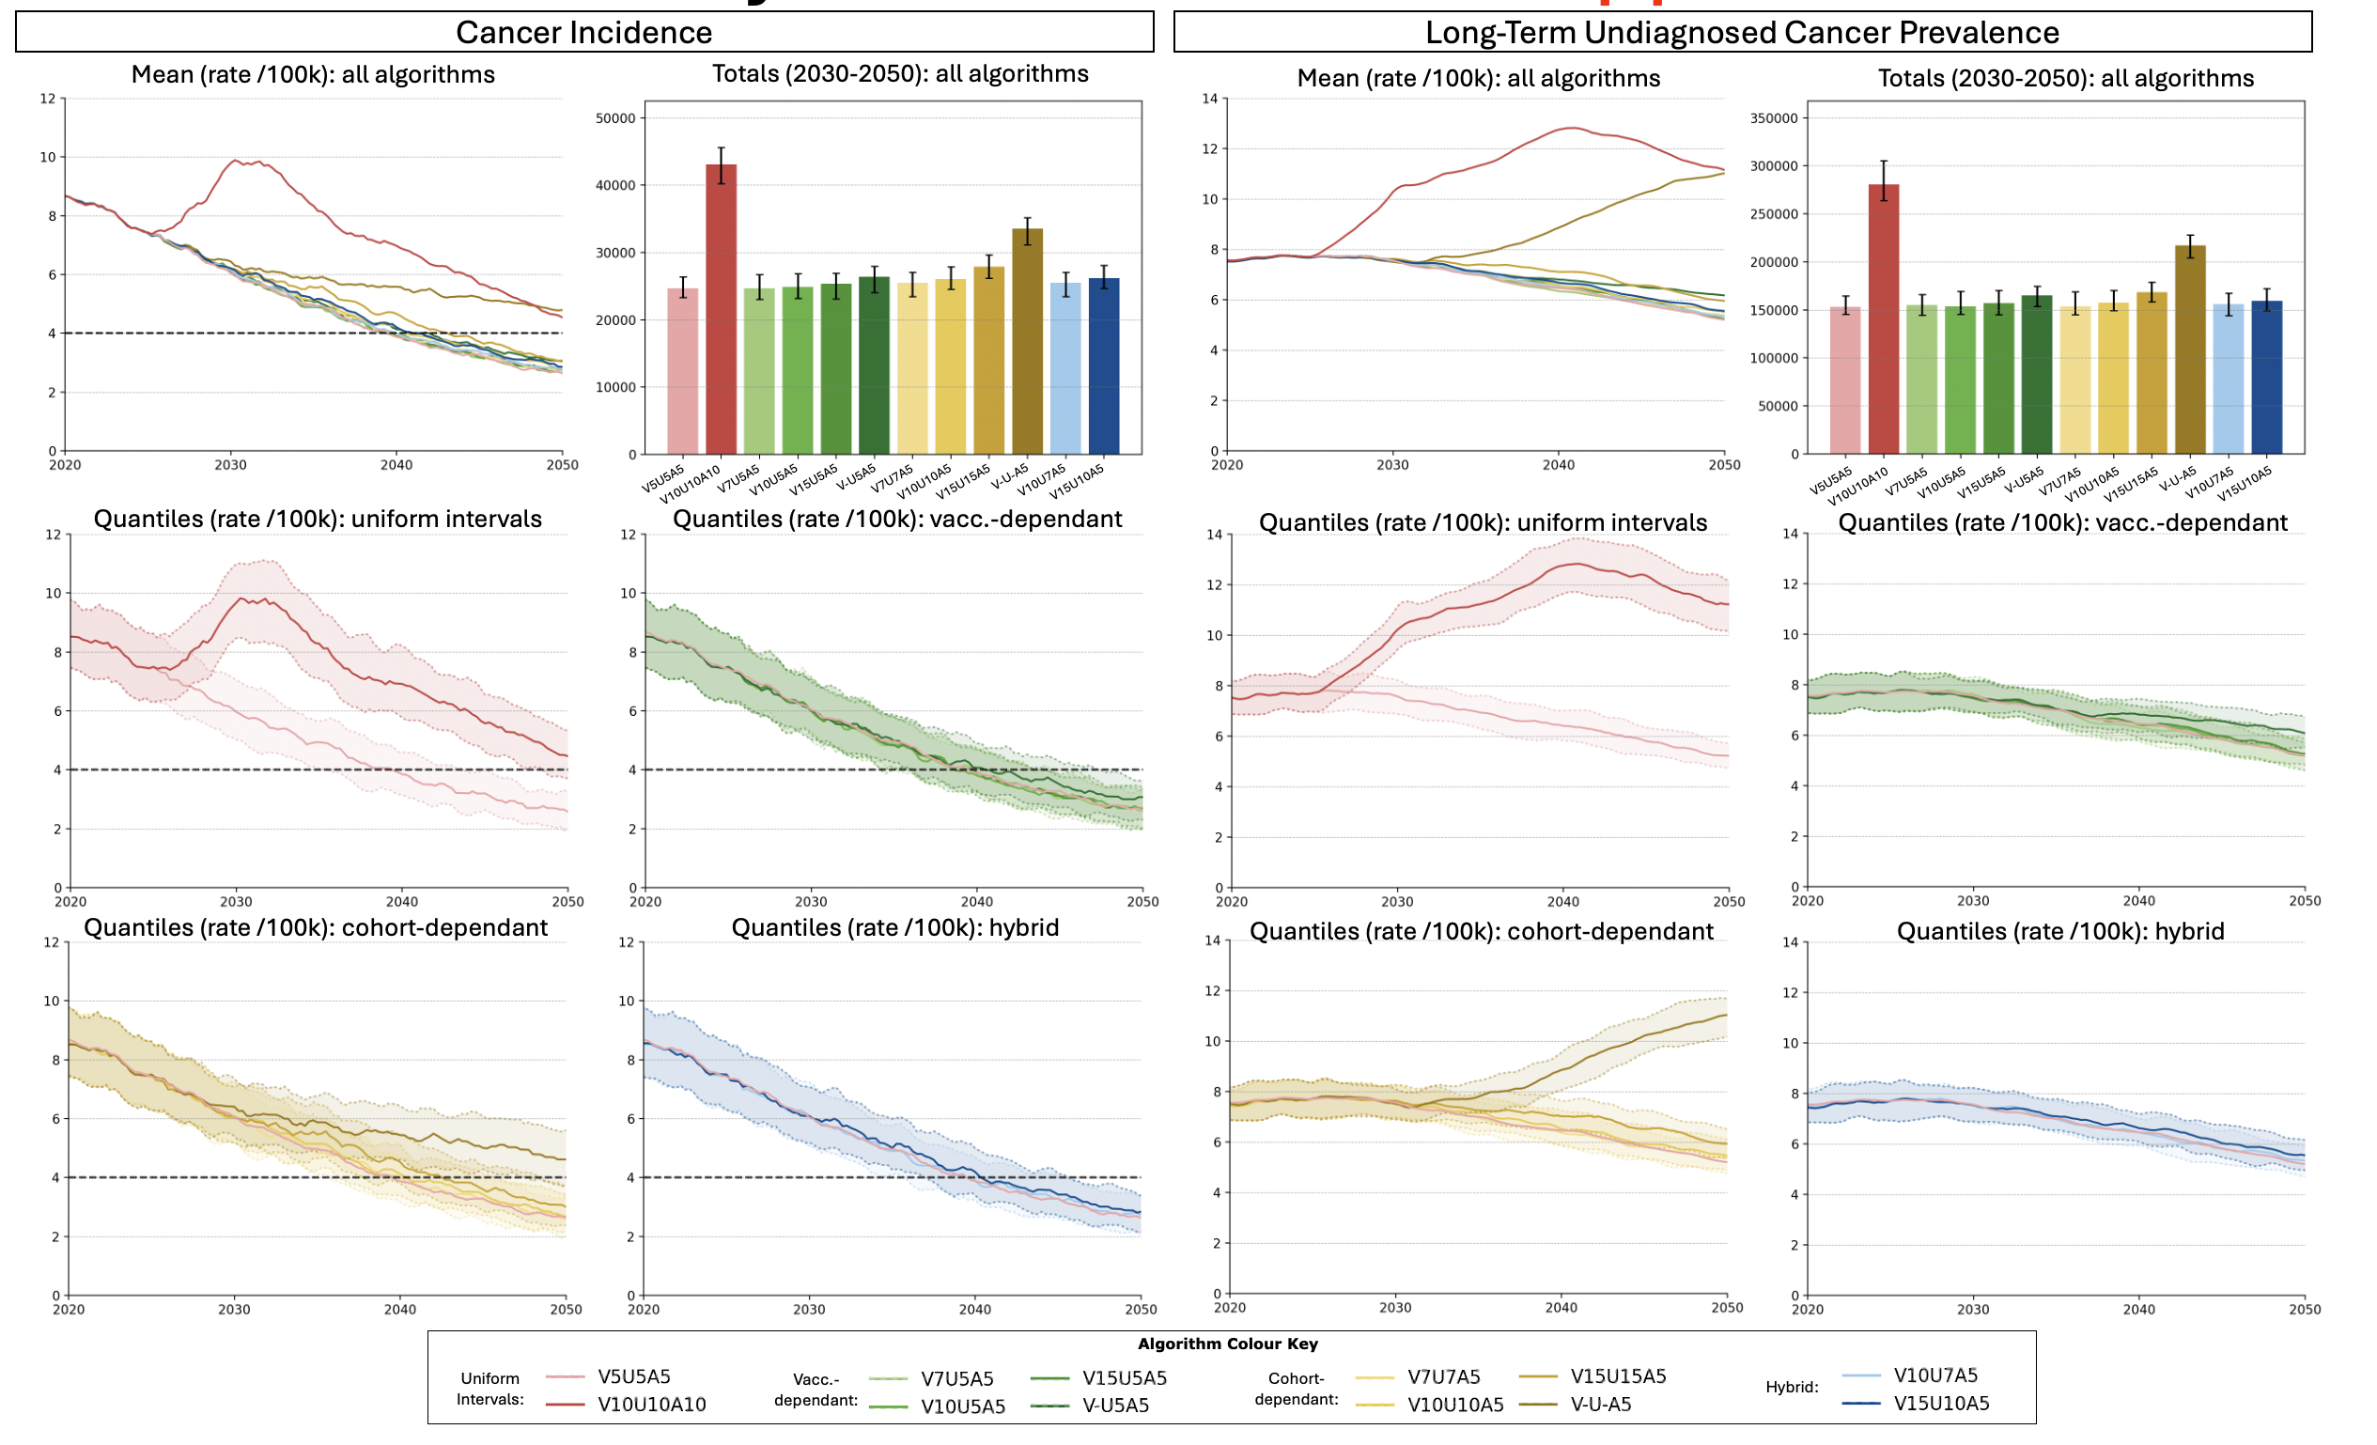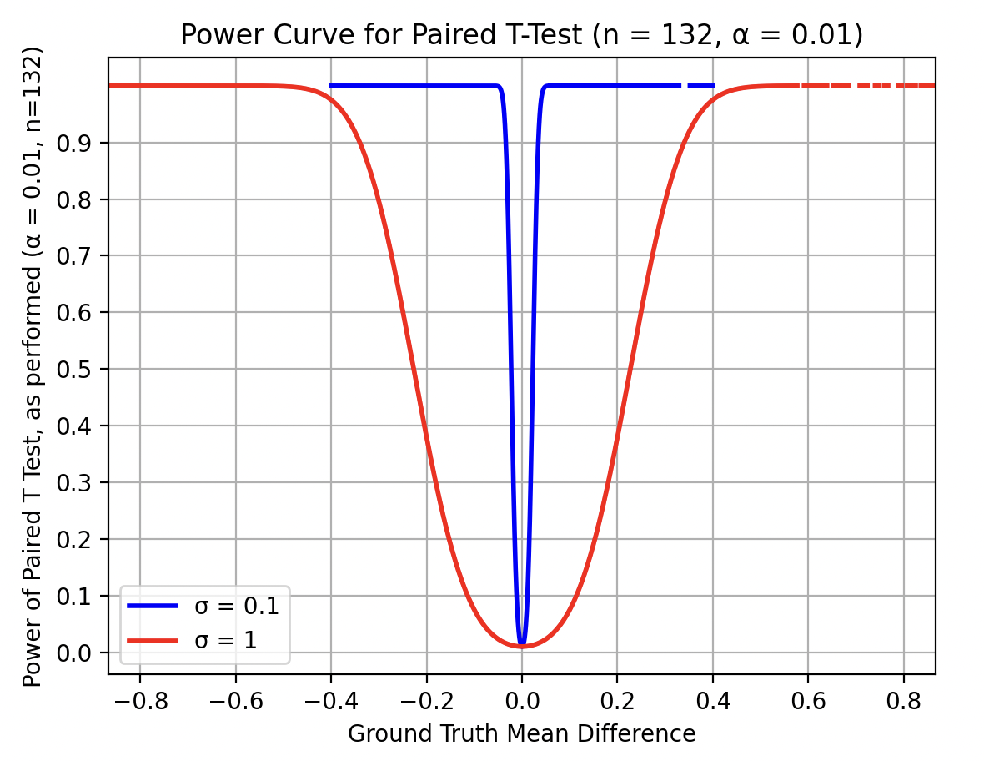

We project cancer incidence and Long-Term Undiagnosed cancer Prevalence (LTUP), defined as cervical cancer present for at least five years but not yet detected through screening under 80\% projected vaccine uptake (Figure X). Outcomes are reported as mean (standard deviation) rates per 100,000 susceptible individuals. Scenario comparisons use paired t-tests, with statistical significance defined as p<0.01 and >80\% power to detect mean differences of >=0.3/100k in cancer incidence and >=1/100k in LTUP. When differences are significant, we report effect size with Cohen’s d. Unless otherwise specified, comparisons are against continued current screening (V5U5A5).

At the population level, most screening algorithms produced similar incidence and LTUP projections. The exceptions were uniform 10-yearly screening across all groups (V10U10A10) and the cessation of routine screening for vaccine-eligible individuals, even whe current screening was retained for the vaccine-ineligible population (V-U-A5). The Agent-Based HPVsim model captures high aleatoric uncertainty through its stochastic structure, alongside increasing epistemic uncertainty as the model extrapolates further into the future. Incidence and LTUP showed consistent patterns across scenarios. Chiefly, all other assumptions held constant, population-level outcomes in the short- to medium-term are primarily driven by screening frequency in the older, vaccine-ineligible, population. A uniform reduction from 5 to 10-yearly screening increases incidence in 2040 from 3.9±0.6 to 7.0±1.1 per 100k (p<.001; d=3.09), and LTUP from 26±3 to 51±6 per 100k (p<.001; d=4.55). In contrast, restricting this screening frequency reduction to vaccinated or vaccine-eligible individuals had much smaller effects, with unchanged LTUP in 2040.

Targeted reduction of screening frequency among vaccinated individuals has little population-level impact up to 15-yearly screening. Reducing screening from 5-yearly to 15-yearly conserved mean projected incidence in 2040 (p=.45) and mildly increased mean projected incidence from 2.6±0.6 to 2.7±0.5 in 2050 (p<.001; d=0.18). LTUP showed no change at the population-level (p=.30/.73 in 2040/50).

Elimination of routine screening for vaccinated individuals worsened projected cancer outcomes at the population level, with increasing effect size over time. Incidence increased to 4.1±0.8 per 100k in 2040 (p<.001; d=0.34), and 3.1±0.7 per 100k in 2050 (p<.001; d=0.58). LTUP increased to 27±3 per 100k in 2040 (p<.001; d=0.40) and 25±4 per 100k in 2050 (p<.001; d=0.84).

Reduction of screening frequency for all vaccine-eligible individuals down to 10-yearly has little population-level impact, whereas larger reduction produced more substantial increases in both incidence and LTUP. Screening every 7, 10, or 15 years, or never, yielded projected incidence rates of 4.0±0.6, 4.2±0.7, 4.7±0.8, and 5.6±0.8 per 100k in 2040 (p=.11/<.001/<.001/<.001; d=-/0.38/0.98/1.98). This increase is maintained until 2050, with incidences 2.7±0.6, 2.8±0.5, 3.0±0.6, and 4.8±1.1 per 100k (p=.27/.01/<.001/<.001 ; d=-/0.22/0.56/2.06). LUDP was maintained for 10-yearly screening, but increased substantially at 15-yearly screening (28±4 in 2040, 24±4 in 2050; p<.001; d=0.74/0.82) and at cessation of screening (35±4 in 2040, 44±6 in 2050; p<.001; d=2.06/3.34).

10- and 15-yearly screening of vaccinated individuals can be augmented with 7- and 10- yearly screening of unvaccinated vaccine-eligible individuals respectively without substantial changes in population-level cancer outcome. Algorithms V10U7A5 and V15U10A5 yield incidence rates 4.0±0.7 and 4.2±0.7 per 100k in 2040 (p=.52/<.001; d=-/0.35), and yield 2.8±0.6 and 2.9±0.6 per 100k in 2050 (p=.08/.06) (comparing to V10U5A5 and V15U5A5 respectively). Corresponding LUDP remains at 26±3 in 2040 (p=.02/.10) and 22±4/22±3 in 2050 (p=.08/<.001; d=-/0.39).

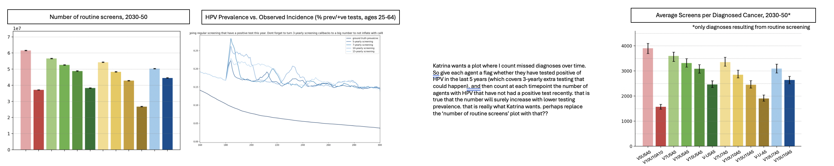
Figure X(a)

Uses of these figures that need to be clarified in discussion:
- Screening is also used for surveillance, so it is important to see how lower frequences affect this. Though I suppose it would probably just be a matter of proportionally lower observed HPV incidence for each subpopulation, but I suppose a simulation to verify that doesn’t hurt?
- Screening does not just impact incidence (though critically it does impact incidence because it can catch CIN and treat with ablation before they develop into cancer, as well as identifying those who are HPV +ve to then screen them more frequently – and this behaviour I do not change as at the point of being identifies as HPV +ve it seems unreasonable to treat people differently depending on vaccine-status and definitely unreasonable depending just on vaccine-eligiblity). In fact, for those who do have cancer, lower screening will mean longer time to diagnosis. Therefore tracking undiagnosed cancer prevalence is important – and long-term undiagnosed cancer prevalence is being tracked as proxy for cancers which have been able to develop for long enough to be a later stage (which is associated with signficiantly worse prognoses).
  - This also requires proper statistical testing between screening algorithms in terms of this metric, therefore
  - Of course, if it turns out the relative patterns /relationships between different screening algorithms are the same for both ludp and incidence, then I can continue to use incidence throughout and don’t need to both much about this other than at this one section in order to make that argument that the two metrics agree in terms of the best screening algorithm
  - In that case, I think Long term undiagnosed cancer prevalcne could be taken away from the equity analysis as it adds potentially unnecessary detail; instead lets look at these alternative metrics here (also considering subpopulations iff needed, and if it does turn out to be needed then we will do the first equity analysis and then to the alternative metrics underneath it with the equity analysis immediately ‘built in’ instead)
- Screens/diagnosis is a metric closely related to health economics and therefore an important one to include for that

Detail for RESULT 2
“Screening according to vaccine-eligibility leads to greater inequity with worse outcomes for the unvaccinated vaccine-eligible as screening frequency decreases (incidence rate 8/6/4 LS: 0.9/1.3/1.7 2050). In contrast, a screening reduction for vaccinated individuals from 8 to 4 LS has negligible impact amongst the vaccinated (8/6/4 LS: 0.1/0.2/0.2 incidence rate 2050), but incidence increases at lower screening frequencies (3LS: 0.4 incidence rate 2050).”

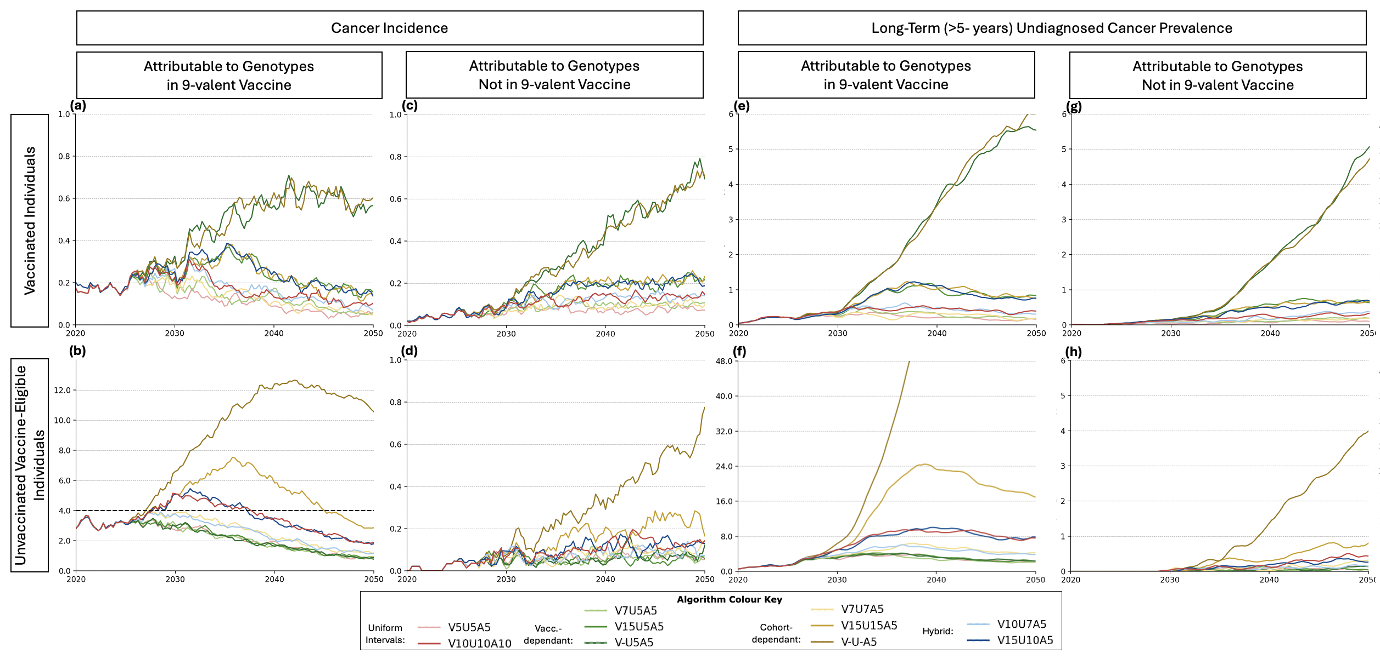

- But do not forget to look for the t values and interpret using cohen’s d as clearly some effect sizes are larger than others even when significant! https://www.statology.org/interpret-cohens-d/

We perform a subpopulation analysis,

Detail for RESULT 3
“While a reduction in vaccine uptake to 60\% will require more total screening for unvaccinated people across the population, individual lifetime screens can remain at 6 LS for the unvaccinated vaccine eligible and 4 for the vaccinated to retain current incidence rate projections.”

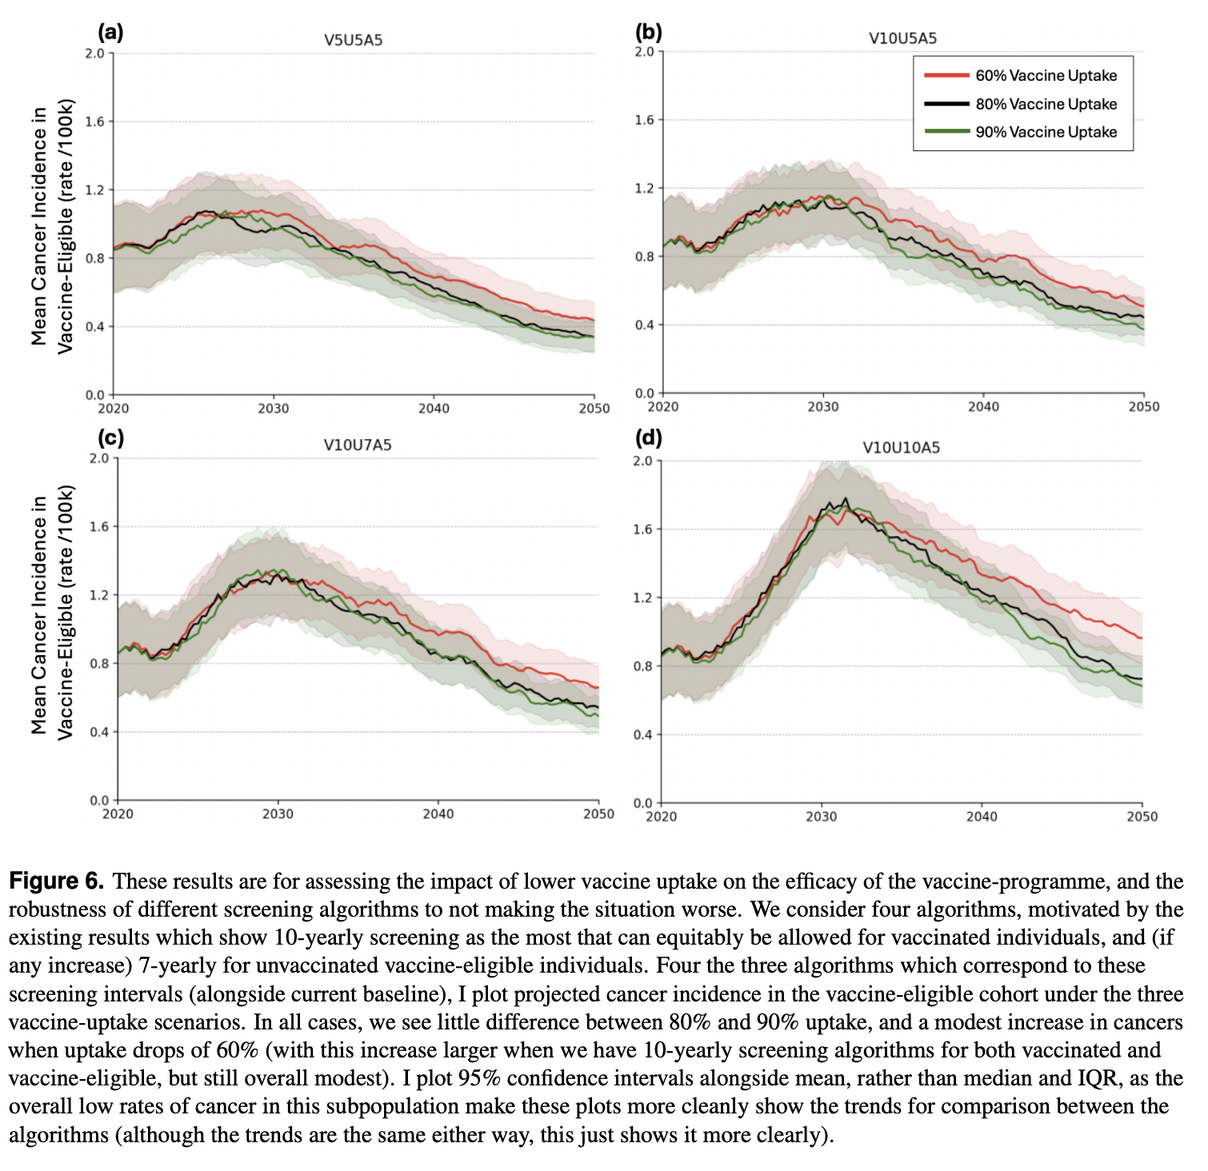
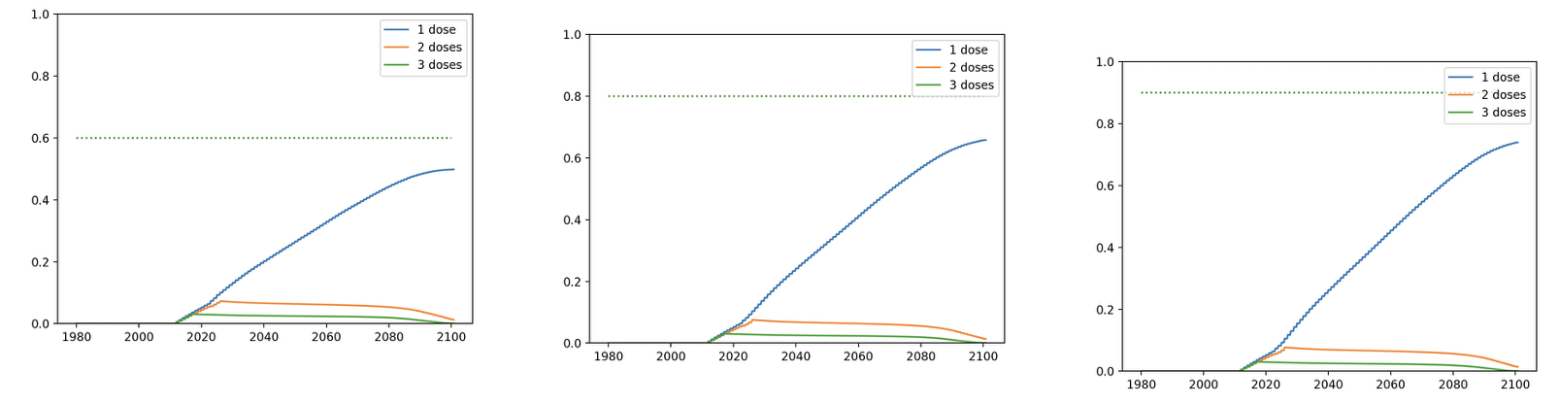

Detail for RESULT 4
“Under the current English screening policy, population-level cervical cancer elimination is unlikely by 2040 (elimination probability 22\%), more likely by 2045 (elimination probability 75\%) and very likely by 2050 (X)”
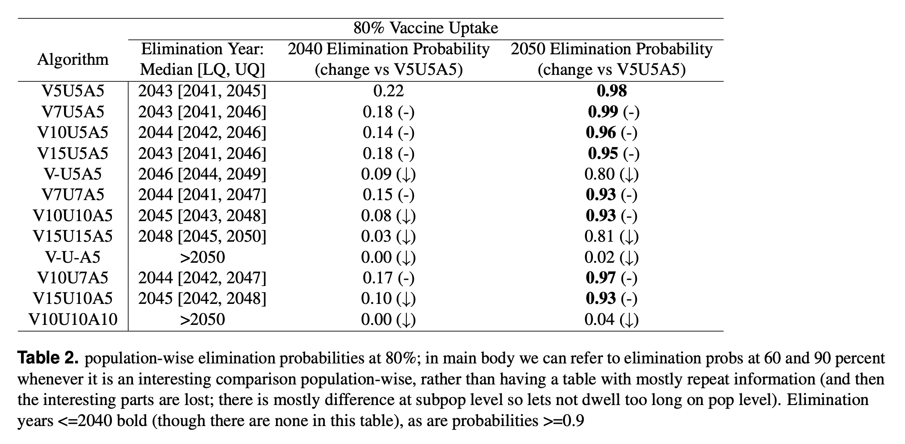
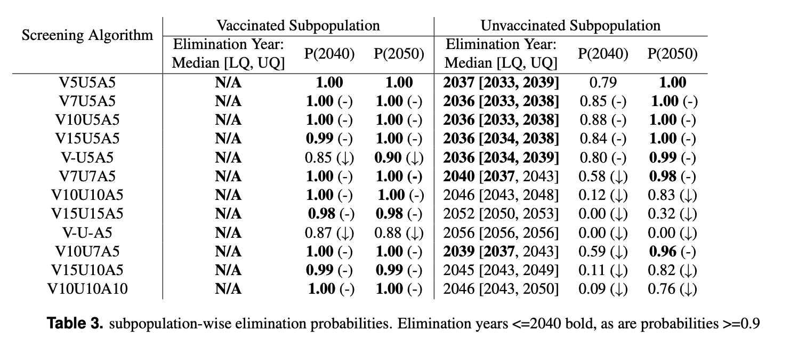

Discussion points from which the abstracts conclusions are derived
[to be added]

Comparing our results + discussion points to literature
[to be added]

Limitations
[to be added]

